Program No.: 06

**Aim:**

Develop a dictionary and Implement dictionary operations in python.

**Topics covered:**

Implementing Dictionaries in Python.

**Course Outcome**

CO2: Implement basic data structures in python***.***

Cognitive Level: K3.

**Case Studies:**

***Case Study 01:***

***Problem Statement:***

* Python script to print a dictionary where the keys are numbers between 1 and 15 (both included) and the values are square of keys.

***Problem Solution:***

1. Take a keys as input.

2. Store the square value of the key in its value.

3. Print Dictionary.

***Program/Source Code:***

#Python program to create a dictionary with 1-15 numbers as keys and its squares as values

"""

Case Study : 01

File Name : cse1.py

Topic : Dictionary

"""

#taking an empty dictionary

dict={}

for i in range(1,16):

dict[i]=i*i

for i in dict.items():

Print(i)

***Program Explanation:***

1. Take a keys as input.

2. Store the square value of the key in its value.

3. Print Dictionary.

***Runtime Test Cases:***

1. (1,1)

(2,4)

(3,9)

(4,16)

(5,25)

(6,36)

(7,49)

(8,64)

(9,81)

(10,100)

(11,121)

(12,144)

(13,169)

(14,196)

(15,225)

**Output:**

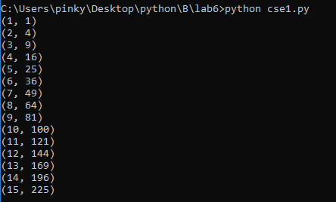

***Case Study 02:***

***Problem Statement:***

* Python Program to Check if a Given Key Exists in a Dictionary or Not

***Problem Solution:***

1. Declare and initialize a dictionary to have some key-value pairs.

2. Take a key from the user and store it in a variable.

3. Using an if statement and the in operator, check if the key is present in the dictionary using the dictionary.keys() method.

4. If it is present, print the value of the key.

5. If it isn’t present, display that the key isn’t present in the dictionary

***Program/Source Code:***

#Python Program to Check if a Given Key Exists in a Dictionary or Not

"""

Case Study : 02

File Name : cse2.py

Topic : Dictionary

"""

dict={‘1’:'a','A':1}

i=input("Enter a key to check :")

if i in dict:

print("Key is present and value of key is ",dict[i])

else:

print("Key is not present”)

***Program Explanation:***

1. Declare and initialize a dictionary to have some key-value pairs.

2. Take a key from the user and store it in a variable.

3. Using an if statement and the in operator, check if the key is present in the dictionary using the dictionary.keys() method.

4. If it is present, print the value of the key.

5. If it isn’t present, display that the key isn’t present in the dictionary

***Runtime Test Cases:***

1.Enter a key to check : 1

Key is present and value of key is a

2.Enter a key to check : 2

Key is not present

**Output:**

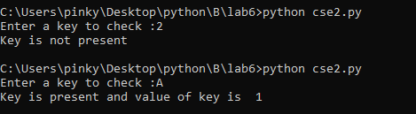

***Case Study 03:***

***Problem Statement:***

* Python Program to Create a Dictionary with Key as First Character and Value as Words Starting with that Character.

***Problem Solution:***

1. Enter a string and store it in a variable.

2. Declare an empty dictionary.

3. Split the string into words and store it in a list.

4. Using a for loop and if statement check if the word already present as a key in the dictionary.

5. If it is not present, initialize the letter of the word as the key and the word as the value and append it to a sublist created in the list.

6. If it is present, add the word as the value to the corresponding sublist.

7. Print the final dictionary.

8. Exit.

***Program/Source Code:***

#Python Program to Create a Dictionary with Key as First Character and Value as Words Starting with that Character.

"""

Case Study : 03

File Name : cse3.py

Topic : Dictionary

"""

st1=input("Enter a string :")

st2=st1.split(" ")

dict={}

for i in st2:

if i[0] not in dict:

dict[i[0]]=[i]

else:

dict[i[0]].append(i)

print(dict)

***Program Explanation:***

1. Enter a string and store it in a variable.

2. Declare an empty dictionary.

3. Split the string into words and store it in a list.

4. Using a for loop and if statement check if the word already present as a key in the dictionary.

5. If it is not present, initialize the letter of the word as the key and the word as the value and append it to a sublist created in the list.

6. If it is present, add the word as the value to the corresponding sublist.

7. Print the final dictionary.

8. Exit.

***Runtime Test Cases:***

1. Enter a string : I love Ipkknd

{'I': ['I', 'Ipkknd'], 'l': ['love']}

2.Enter a string : I am kundana

{'I': ['I'], 'a': ['am'], 'k': ['kundana']}

**Output:**

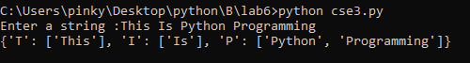

***Case Study 04:***

***Problem Statement:***

Python program to create and display all combinations of letters, selecting each letter from a different key in a dictionary.

***Problem Solution:***

1. First we are creating a dictionary with the required elements.

2. Declare an empty list and declare with size 4.

3. By using for loops we are accessing the elements of the dictionary and we are concatenating the elements and stored in the list element.

4. Printing the list.

5. Exit.

***Program/Source Code:***

#Python program to create and display all combinations of letters

"""

Case Study : 04

File Name : cse4.py

Topic : Dictionary

"""

dict = {1:['a','b'],2:['c','d']}

lis = [None]*4

k=0

#Logic to create the letter combination

for i in dict[1]:

for j in dict[2]:

lis[k] = i+j

k+=1

#Printing the combination of letters

print(lis)

***Program Explanation:***

1. First we are creating a dictionary with the required elements

2. Declare an empty list and declare with size 4.

3. By using for loops we are accessing the elements of the dictionary and we are concatenating the elements and stored in the list element.

4. Printing the list

5. Exit.

***Runtime Test Cases:***

['ac', 'ad', 'bc', ‘bd']

**Output:**



**Result:**

Implementation of developing a dictionary and implementing dictionary operations in python done successfully.